

PHYSICS
UNIT 1

Semester One Examination 2018

Question/Answer Booklet

Name: ____________________________________________________________________

Teacher: Edmunds

Time allowed for this paper:
Reading time before commencing work: 10 minutes
Working time for paper: 2.5 hours

Materials required/recommended for this paper
To be provides by the supervisor
This Question/Answer Booklet
Formulae and Data Booklet

To be provided by the candidate
Standard items: pens, pencils (including coloured), sharpener, correction fluid, eraser, ruler, highlighters.
Special items: up to three non-programmable calculators approved for use in the WACE examinations, drawing templates, drawing compass and a protractor.

STRUCTURE OF THIS PAPER

Section | No. of  Questions | No. of questions  to be attempted | Suggested working time  (minutes) |  | Marks available | Percentage of  exam
Section one  Short Response | 10 | ALL | 45 |  | 44 | 30
Section two  Problem Solving | 5 | ALL | 70 |  | 70 | 45
Section three  Comprehension | 2 | ALL | 35 |  | 36 | 25
 |  |  |  | Total | 150 | 100

INSTRUCTIONS TO CANDIDATES

Write your answers in the spaces provided beneath each question. The value of each question (out of 150) is shown following each question.

Answers to questions involving calculations should be evaluated and given in decimal form. Final answers should be given up to three significant figures and include appropriate units.

Questions containing the instruction "ESTIMATE" may give insufficient numerical data for their solution. Give final answers to a maximum of two significant figures and include appropriate units.

Despite an incorrect final result, credit may be obtained for method and working providing these are clearly and legibly set out.

Questions containing specific instructions to show working should be answered with a complete, logical, clear sequence of reasoning showing how the final answer was arrived at; correct answers which do not show working will not be awarded full marks.

You must be careful to confine your responses to the specific questions asked and follow any instructions that are specific to a particular question.

Spare pages are included at the end of this booklet. They can be used for planning your responses and/or as additional space if required to continue an answer.

  - Planning: If you use the spare pages for planning, indicate this clearly.
  - Continuing an answer: If you need to use the space to continue an answer, indicate in the original answer space where the answer is continued, i.e. give the page number. Refer to the question(s) where you are continuing your work.

Section One: Short Response 30% (44 marks)

This section has 10 questions. Answer all questions. Answer the questions in the spaces provided.
Suggested working time: 45 minutes.

Question 1 (5 marks)

Two substances with the same mass are made up of pure metals. One is pure gold and another one is pure copper. The specific heat capacities of gold and copper are 130 J kg⁻¹ K⁻¹ and 390 J kg⁻¹ K⁻¹, respectively.

- Explain what it is meant by 130 J kg⁻¹ K⁻¹.
(2 marks)

- With the same amount of energy being transferred to each metal, which metal will have the greatest change in temperature? Use appropriate formulae to support your answer.
(3 marks)

Question 2 (4 marks)

Complete the following nuclear equations and name the particle / radiation types.
(4 marks)

- ${}_{92}^{239}U→ {}_{90}^{235}{Th+}$ __________________________ Name of the particle: __________________

- ${}_{38}^{90}{Sr→ {}_{39}^{90}{Y+}}$___________________________ Name of the particle: __________________

Question 3 (4 marks)

Sue wants to lower the temperature of her stainless-steel barbecue plate from 400 ºC to 180 ºC by spraying water directly onto the 25.0 kg plate.

Calculate the mass of water, initially at 20.0 ºC, required to cool the barbecue plate. Assume all water completely evaporates to steam at 100 ºC and that there is no energy lost to the environment. The specific heat capacity of the stainless-steel is 450 J kg⁻¹ K⁻¹.

Question 4 (3 marks)

The Fukushima nuclear disaster in March 2011 was a result of a combined earthquake and tsunami. Radioactive caesium and iodine were released into the atmosphere and, while most of Japan’s population received little additional radiation, workers at the plant itself received, on average, 400 mSv.

Determine the amount of energy in joules that a worker with a mass of 57.0 kg could have received from radiation in the accident if caesium and iodine are both beta and gamma emitters.

Question 5 (4 marks)

“The Fremantle Doctor” is the local term for the cooling afternoon sea breeze which occurs during summer time around the south west area of Western Australia. This sea breeze occurs because of the major temperature difference between the land and sea.

Explain this phenomenon using physics concepts and include a diagram to assist your answer.

Question 6 (2 marks)

Strontium-90 emits beta particles which are used for thickness control of paper and plastic film in manufacturing industry. Explain why alpha particles and gamma rays are not able to do the same job as beta particles.

Question 7 (9 marks)

A voltage source is connected across a light bulb and the current is recorded for different voltages. The graph is shown below.

- Draw a line of best fit for the data shown in the graph above.
(1 mark)
- State the range of voltages where the light bulb is ohmic.
(1 mark)
Range: _______________________________________

- Use the graph above to calculate the resistance of the light bulb when it is ohmic.
(3 marks)

- Calculate the resistance of the light bulb when the voltage is at 80 V.
(2 marks)

- Explain the difference in values for part c) and d).
(2 marks)

Question 8 (5 marks)

The initial activity of a radioactive source an isotope of Radon is 180 Bq. The half-life of Radon is 4.00 days.

- Calculate the activity of Radon after 16 days.
(2 marks)

- Plot the time variation of activity of the source from 0 to 12.0 days. [An additional graph is available on page 27 if required.]
(3 marks)

Question 9 (4 marks)


A rating of a battery is “1.20 V, 1600 mA”. The battery is used for 1.00 hour.

- Calculate the total charge passing through the battery.
(2 marks)

- Calculate the total useful energy released by the battery, if the battery is 80.0% efficiency.
(2 marks)

Question 10 (4 marks)

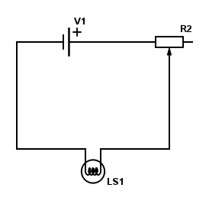
The diagram on the right shows a light bulb and a rheostat that are being connected with a 12.0 V battery.

- On the diagram, draw an arrow showing the electron current.
(1 mark)

- Explain how the rheostat could affect the brightness of the light bulb. Use some equations to assist your answer.
(2 marks)

- If the rheostat is set to the maximum, the light bulb will be: (circle the answer)
(1 mark)

Brighter Dimmer No effect to the brightness

END OF SECTION ONE
Section Two: Problem-solving 45% (70 marks)

This section contains 5 questions. Answer all questions. Answer the questions in the spaces provided.
Suggested working time 70 minutes.

Question 11 (8 marks)

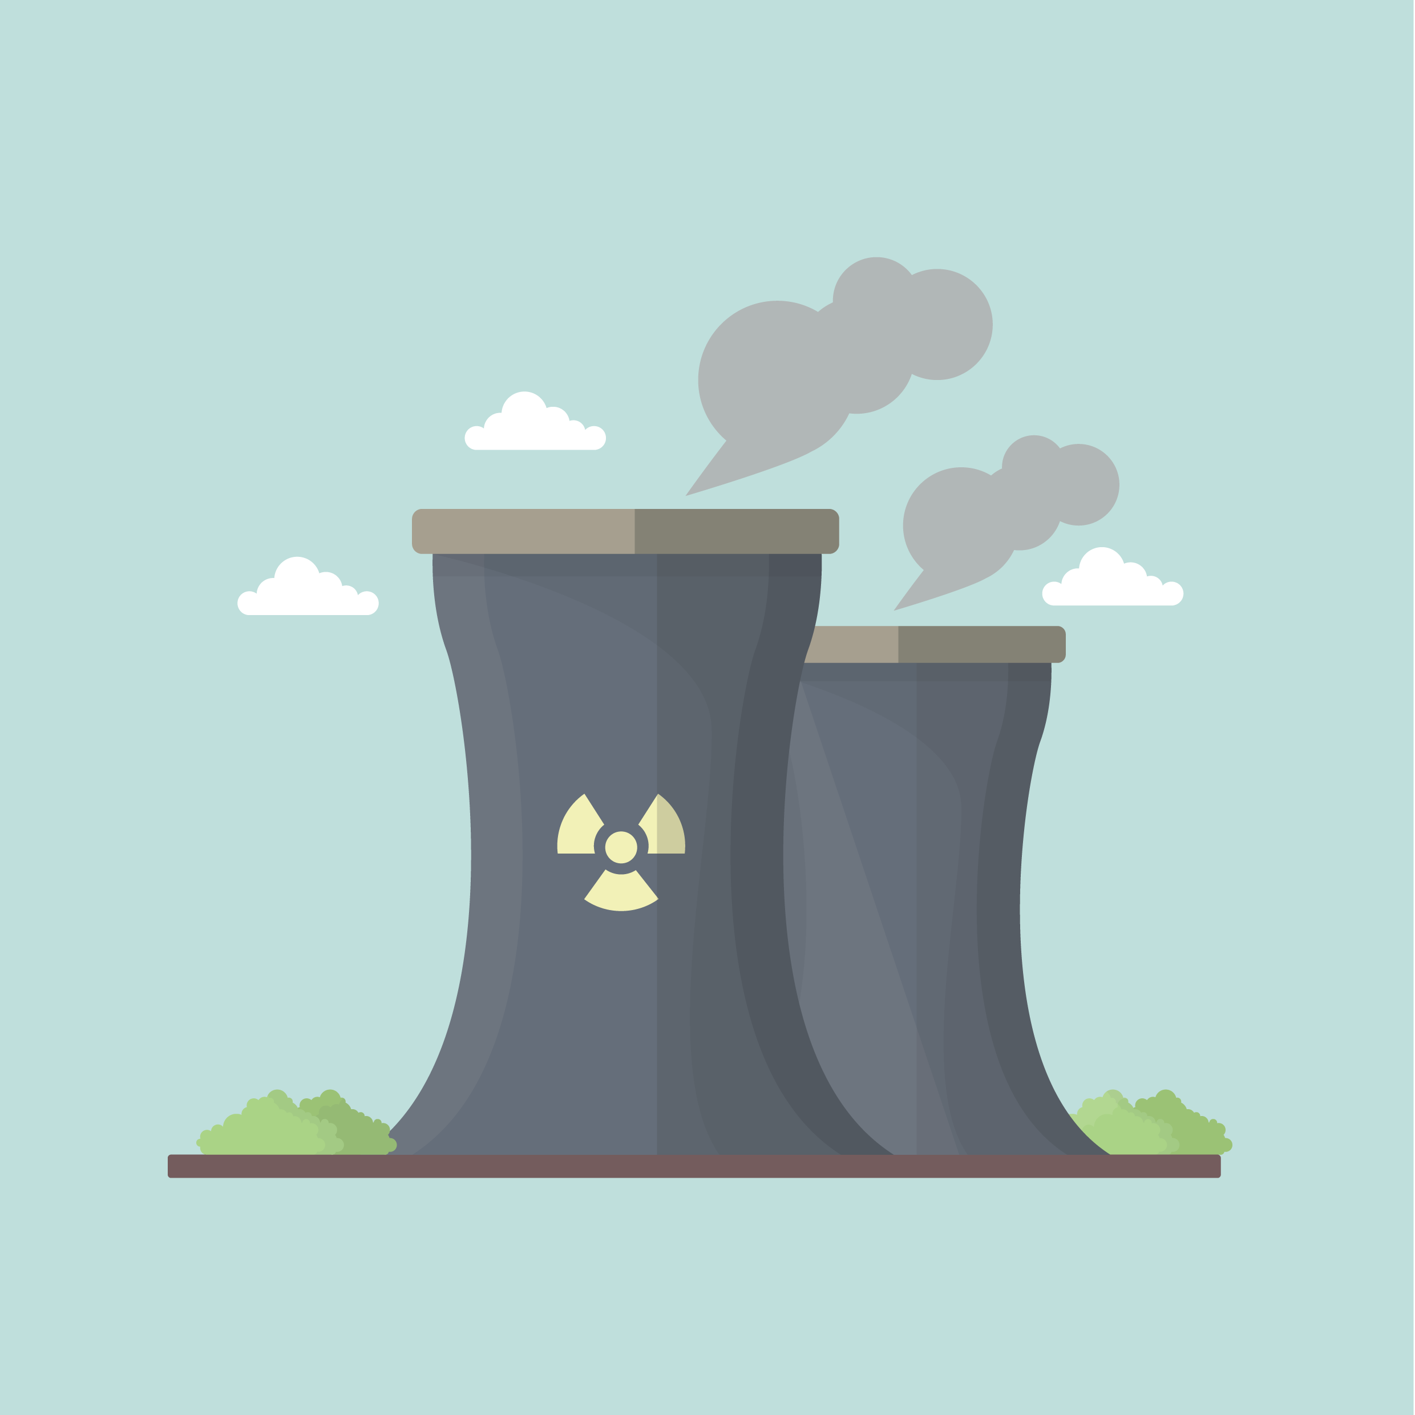
In a fast breeder reactor, a neutron, mass 1.00867 u, causes fission of Pu-239 (239.05216 u). One of the two fission fragments is Tc-104 (103.91145 u) and three neutrons are released. The atomic mass of the other fragment is 132.91525 u.
.
- Construct the decay equation as outlined in the text.
(2 marks)

- Calculate how much energy, in MeV, is produced by this nuclear reaction. Show all working clearly.
(3 marks)

- If the average power consumption for Perth city is 600 MW daily, calculate the mass of Pu-239 (in kg) required to provide Perth city with enough energy for 30 days.
(4 marks)

Question 12 (16 marks)

The following graph shows the cooling curve of 1.00 kg of naphthalene from liquid to solid over 18.0 minutes. The naphthalene releases energy at a rate of 350W(Js⁻¹) as it cools from 90.0 ºC.

- On the graph above, label the time when the naphthalene is in a liquid state.
(1 mark)

- Use kinetic theory to explain why the curve stays flat between 3.00 minutes and 11.0 minutes.
(3 marks)

- A value for the latent heat of fusion can be found using the curve.

- Calculate the total energy released between 3.00 minutes and 11.0 minutes.
(2 marks)

ii) Hence, determine a value for the latent heat of fusion. Write the correct unit.
(3 marks)

- Use the graph to estimate the specific heat capacity of the solid naphthalene.
(4 marks)

- On the graph below, redraw new cooling curves when the following conditions have changed: the mass of the naphthalene is doubled; the rate of energy lost is the same as before and the initial temperature stays at 90.0 ºC. [An additional graph is available on page 27.]
(3 marks)

Question 13 (18 marks)

A quality-control officer tests a strand of nylon cord by subjecting it to various loads (force) and recording the subsequent extensions. The diagram on the right shows the equipment used. The original length of the nylon string is 100 mm.
load
Nylon cord
length

The idea is to determine the stretch constant(k) for the nylon.

The relationship for the stretch constant is:

F = kΔX

- Complete the following:
(2 marks)

Independent variable: __________________________

Dependent variable: ___________________________

- Complete the table.
(1 mark)
F: Load, in Newtons
L: Length, in millimetres
ΔX: Extension or change of length to 100 mm (initial length).

F (N) | 0 | 10 | 20 | 30 | 40 | 50
L (mm) | 100 | 108 | 117 | 124 | 132 | 139
ΔX (mm)

- Calculate the percentage uncertainty for the length of the nylon string if the load is 20 N.
(2 marks)

- Plot a graph using load on the “y” axis and ΔX on the “x” axis(See the next page). Label all axes with appropriate units. [An additional blank graph is available on page 28.]
(5 marks)
- Calculate the gradient of the graph. Show all working out clearly. Include all units.
(4 marks)

- What does the gradient tell you about the string?
(1 mark)

- Estimate the length of the nylon when 60 N of load is used. Show clear working.
(3 marks)

Question 14 (18 marks)

As shown below, six resistors are connected in a network to a 12.0 V battery (V1). The values of the resistors are also shown below:
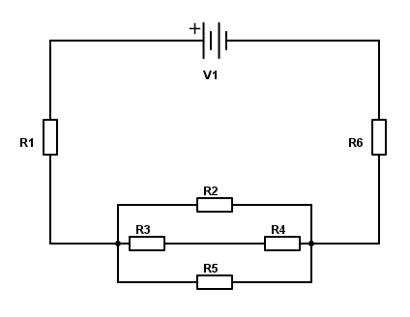
R1 = 10.0 Ω
R2 = 12.0 Ω
R3 = 4.00 Ω
R4 = unknown
R5 = 6.00 Ω
R6 = 20.0 Ω

- On the diagram above, draw an arrow to show the direction of conventional current through resistor R1.
(1 mark)

- On the diagram above, show how you would connect a voltmeter to measure the voltage of R2.
(1 mark)

- Outline what the voltmeter in part ii) is effectively measuring, in terms of the charge flowing through R2.
(2 marks)

It is found that the circuit current measured in the main circuit is 0.371 A.

- Calculate the voltage across resistor R1 and R6. Show all working below.
(2 marks)

- Hence, determine the voltage across R2.
(2 marks)

- Show that the current flowing through R4 is 0.153 A. Show all clear working.
(5 marks)

- Hence determine the resistance of R4.
(3 marks)

- If resistor R4 burns out, would the circuit current increase or decrease? Explain your answer. No calculations are required.
(2 marks)

Question 15 (11 marks)

A catering food warmer consists of two compartments: a stainless steel food tray which holds the food and a hot water bath tray beneath it.


Food Tray

Hot Water Tray

- Use appropriate physics concepts and the diagram above to explain how hot water bath is able to reheat the food.
(3 marks)

- The 2.50 kg of food in the food tray has dropped to 40.0 ºC. Calculate the volume (in L) of 100 ºC water required to warm the food back to 60.0 ºC. The mass of the food tray is 2.00 kg. The specific heat capacity of food is 6000 J kg⁻¹ K⁻¹ and the specific heat capacity of the stainless-steel is
450 J kg⁻¹ K⁻¹. Assume 20.0% heat lost to other areas and the density of water as 1.00 kg L⁻¹.
(5 marks)

- Use your understanding of heating and cooling methods to explain the benefits of using a lid on the food warmer.
(3 marks)

END OF SECTION TWO
Section Three: Comprehension 25% (36 marks)

This section has two questions. Answer both questions. Answer the questions in the spaces provided.
Suggested working time: 35 minutes.

Question 16 (18 marks)
When the weather warms up, pop on cooling clothes
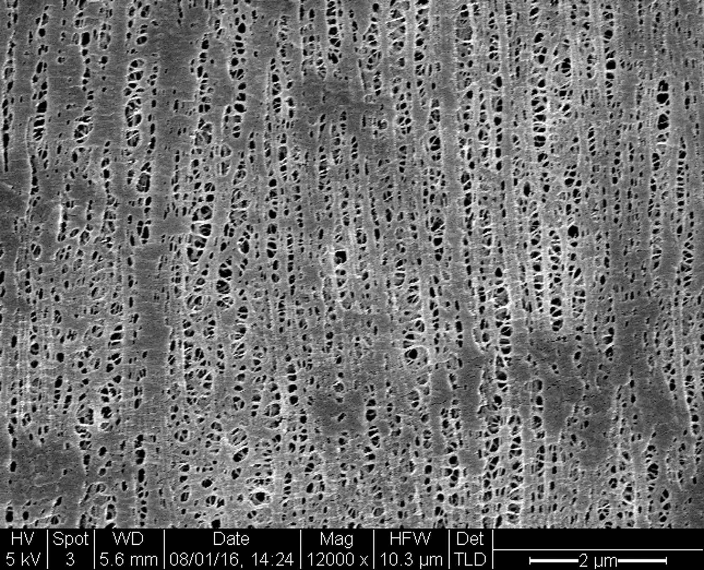
You might add layers when the thermostat drops, but could clothing actually help you cool off too? Stanford University researchers have found a way. Anthea Batsakis reports.

In hot weather, we can only shed so many layers of clothes before it starts to get rude – but now a low-cost material has been invented that cools you down when you start heating up. Developed by researchers at Stanford University, the material reflects sunlight from the body while providing an escape route for heat radiating from our skin.
The fabric is a creative substitute for air conditioning or other indoor cooling devices, Po-Chun Hsu, Yi Cui and colleagues write in Science. They hope the material can be developed on a commercial scale and have a global impact by reducing greenhouse gas emissions.
Figure 1 An electron microscope image of the cooling material. The tiny pores let sweat evaporate.

The human body emits mid-infrared radiation. But this is the core of the cooling problem – wavelengths of our infrared emissions sit so close to visible light on the electromagnetic spectrum, the two overlap a little. This means regular clothes that block visible light from entering also trap body heat. The cool fabric from Stanford, though, lets infrared through, lowering temperatures between 2 °C and 3 °C. It also facilitates air and water vapour flow, making things more manageable when we sweat. It’s made of a flexible and durable version of the thin plastic film you might use in the kitchen to cover food called polyethylene. But unlike cling film, the new material is treated with safe chemicals to create nanoporous polyethylene, which lets water evaporate through tiny pores.

Compared to pure cotton, though, the material is far more “breathable”: cotton only allows 1.5% of infrared waves to pass, while the porous polyethylene clears the way for 96% of infrared waves radiated from our skin. [The remaining heat stays in the human body.] Peter Musk, who also seeks to find sustainable clothing alternatives at the State Library of Queensland in Australia, says it’s important to consider the costs developing this material would have. “This new polyethylene product may well reduce the need for energy use by the end user, but analysis of the total cost to the environment, and greenhouse gas emissions involved in mining, transporting, refining and manufacturing the product might produce a different conclusion about its contribution to sustainability,” Musk says.

In any case, instead of cranking up the air conditioning, you might one day change your clothes instead. The scientists are working on adding more colours and textures to their range over the next few months.

- Explain how the cool fabric from Stanford University might contribute to reduced greenhouse gas emissions.
(3 marks)

- Outline three differences between pure cotton and the cool fabric in terms of cooling the body.
(3 marks)

Pure cotton | Cool fabric
 | .

- Use kinetic theory to explain how evaporation of water from the human body can cause cooling.
(2 marks)

- John, a 75.0 kg runner, generates 8.00 MJ of energy while training for a marathon.

- Calculate the temperature rise of John’s body if he is wearing the cool fabric. Assume the specific heat capacity of an average human body is 3500 J kg⁻¹ K⁻¹. Use data in paragraph four to assist your calculation.
(4 marks)

- Estimate the mass of water needed to evaporate from John’s body to maintain a constant body temperature during this run. (If you could not calculate part i) use a value of 2.00 ºC). Assume evaporation is occurs at the same temperature as John’s body)
(4 marks)

- Describe the difference it would make to John’s body if he were to wear cotton clothes instead. No calculations required.
(2 marks)

Question 17 (18 marks)

Are Canadian fish being poisoned by radiation from Japan?

In 2015, a single salmon caught in Osoyoos Lake in British Columbia was found to contain very low levels of a radioactive isotope called caesium-134.

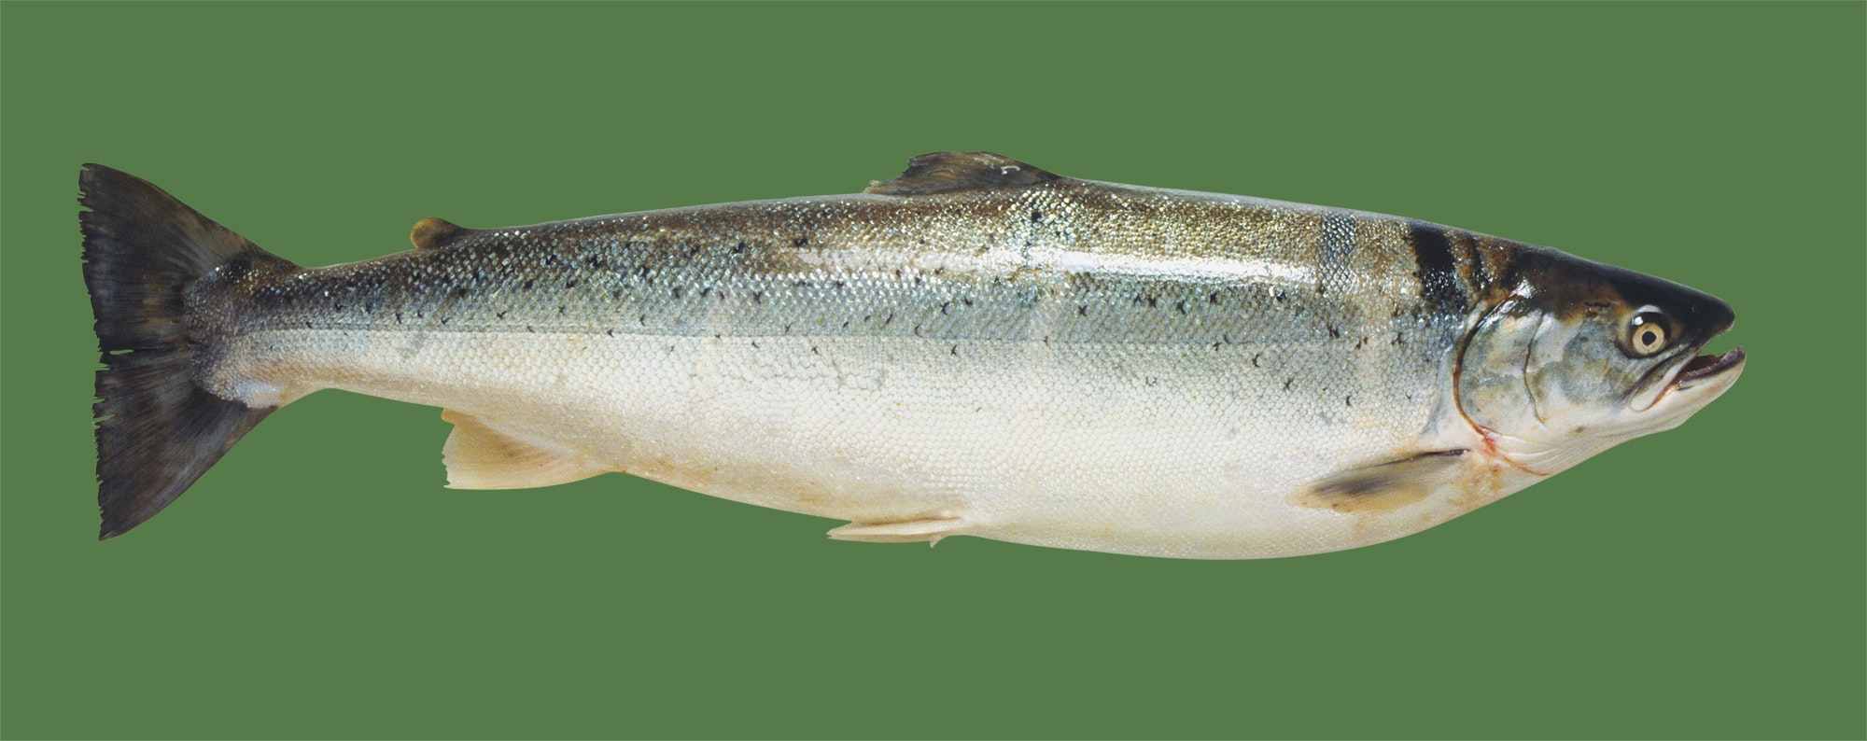
Figure 2 Were salmon in Canada really contaminated with radioactive isotopes from the damaged nuclear power plant at Fukushima in Japan?

A news story has done the rounds on social media this year claiming that salmon in Canada had been found contaminated with radioactive isotopes from the damaged nuclear power plant at Fukushima in Japan.

Is it true? And, if so, is there anything to worry about? The answer to the first question is “yes, sort of”, but the answer to the second is “definitely not”!

The story grew from the fact that, in 2015, a single salmon caught in Osoyoos Lake in British Columbia was found to contain very low levels of a radioactive isotope called caesium-134. The isotope is produced during nuclear fission – the process that drives both atomic power stations and atomic bombs. Because it has a half-life of 2.04 years, any caesium-134 that was released into the atmosphere by previous bomb tests or reactor disasters (such as Chernobyl) has long since decayed away. Therefore, any caesium-134 found in anything at the moment can only have come from Fukushima.
So, yes, a radioactive nasty from Japan did end up in a fish in Canada. However, there is much more to the story than that.

First off, scientists have always predicted that radioactive stuff from the damaged reactor would spread around the world, through the oceans and the air. This is simply what happens. Between 1955 and 1963, for instance, there were a whole bunch of atmospheric nuclear bomb tests, which collectively pumped out a huge amount of an isotope called carbon-14. All over the world, people who were children during that time have higher-than-average levels of it in their muscle tissues.

In 2016, caesium-134 from Fukushima was detected in the waters off the coast of north-western US state of Oregon for the first time. This did not surprise environmental scientists and oceanographers, who had long predicted its eventual arrival. The isotopes detected in the sea were at very low levels and didn’t pose any threat to human health. The same goes for the single Canadian salmon. In fact, the radiation levels detected in the fish were actually lower than the levels found in most other fish around the globe. This is because, every day, every living thing absorbs radiation produced naturally by cosmic rays, some kinds of rocks and minerals, and even the air itself. It’s called “background radiation” and it has been around since the Big Bang.

The suspect salmon wasn’t eaten, because it was used for testing. But if it had been, would it have made the person who ate it ill? Not at all. The standard measurement for radiation in food is a unit called the becquerel. It is always expressed in terms of becquerels per kilogram. The Canadian salmon contained 0.7 becquerels per kilogram. The World Health Organisation’s recommended safe maximum limit for radioisotopes in food is 1,000 becquerels per kilogram. So, should you ever be lucky enough to find yourself hooking a sockeye salmon in Osoyoos Lake, have no fear. Wrap it in foil with a few slices of lemon and some thyme, chuck it on the camp fire, and enjoy!

- Explain why it is important to measure the level of radiation in fish.
(3 marks)

- Fukushima Daiichi reactors exploded in 2011. Now the radiation “stuff” is said to be spread around the word due to water current. Outline why the author does not believe this radiation to be harmful.
(2 marks)

- According to the articles, there are many sources of radiation which could affect our lives. Apart from the nuclear reactor plants, state two more.
(2 marks)

- Calculate the binding energy per nucleon of caesium-134. Express your answer in MeV and show clear working.

Use the following data:

Mass of proton = 1.00727 u
Mass of neutron = 1.00867 u
Mass of Caesium-134 = 133.907 u

(4 marks)

- The caesium-134 undergoes alpha decay followed by a beta positive decay. Write down the two equations of this decay series.
(3 marks)

- A 6.00 kg salmon has eaten food that contains caesium-134 with a radiation level of 384,000 becquerel. Estimate, how long it will take for the salmon to be safe according to the World Health Organisation’s recommended maximum limit.
(4 marks)

END OF SECTION THREE

Extra Space
Extra Space

Extra Graph for question 8

Extra graph for question 12

Extra Graph for question 13

End of Exam

